Group 3:

Palak Agrawal

Tejesh Rathi

Sonali Chaudhari

Abstract

All the PL/SQL Procedures, Triggers, Functions and Cursors are listed with its result set

IMDB

Internet Movie Database

-----------------------------------------------------------------------------------------

/\*Executing ufnGetUserName()\*/

-----------------------------------------------------------------------------------------

SELECT ufnGetUserNameffromemail('agrawal.pala@husky.neu.edu') FROM DUAL;

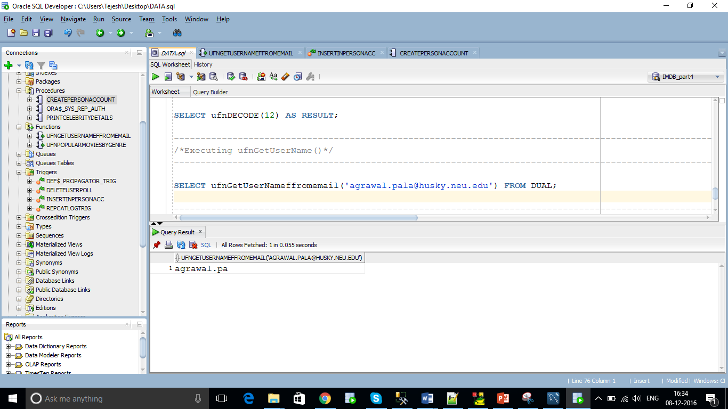

-----------------------------------------------------------------------------------------

/\*Executing ufnPopularMoviesByGenre()\*/

-----------------------------------------------------------------------------------------

SELECT \* FROM TABLE (ufnPopularMoviesByGenre);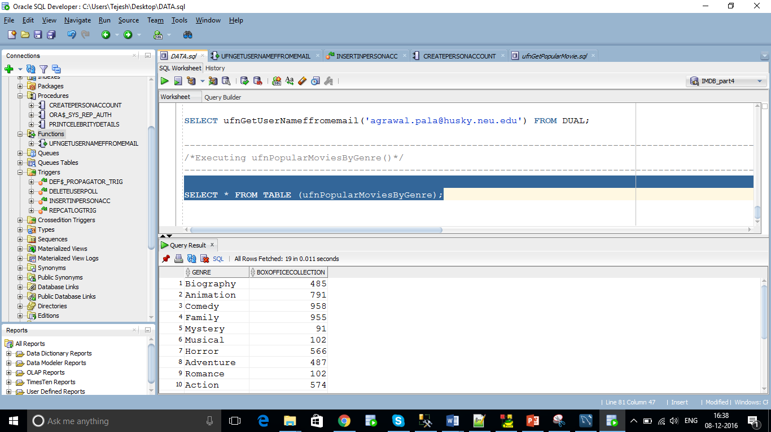

-----------------------------------------------------------------------------------------

/\*Executing printCelebrityDetails\*/

-----------------------------------------------------------------------------------------

SET SERVEROUTPUT ON;

EXEC PrintCelebrityDetails('Brad Pitt');

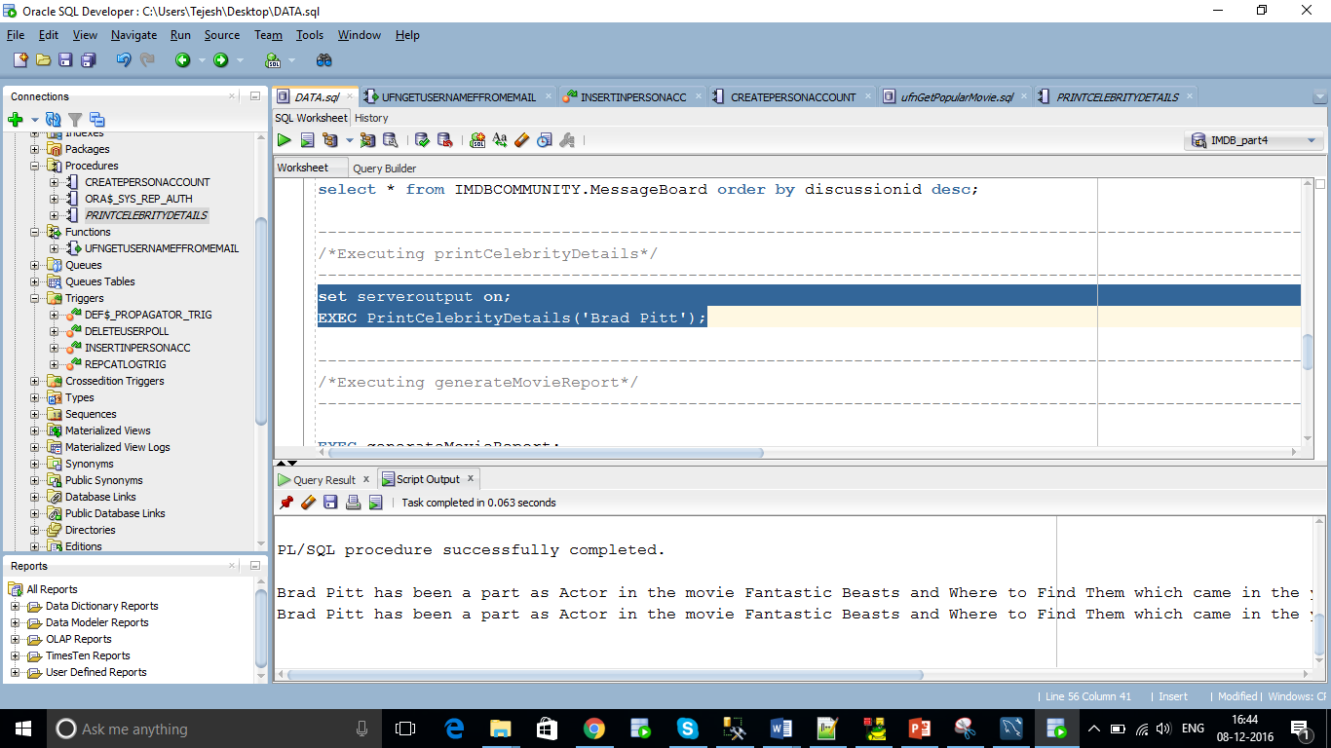

--------------------------------------------------------------------------------------------------------------------------

/\*Executing createPersonAccount()\*/

--------------------------------------------------------------------------------------------------------------------------

EXEC createPersonAccount('Sunita','Agrawal',17,'123SUN','sunita.agrawal@gmail.com');

select \* from Person where PersonID = 17;

select \* from EmailAddress where PersonID = 17;

select \* from PersonAccount where PersonID = 17;

